Julie Kim (Engineering Portfolio)



Los Angeles, CA | 562-607-1465 | [chealy_ljh@yahoo.co.uk](mailto:chealy_ljh@yahoo.co.uk)

<https://github.com/ChealyKim-Engr/Engineering-Portfolio>

* RTL Analog to Digital Converter Custom IP (*Spring 2021 – FPGA Based SW&HW Co-Desgn)*

<https://www.youtube.com/watch?v=VVtr0a4FmV0&list=PLWB9IGreRgxyr_xbJwedF16atCr6rWCUh&index=2>

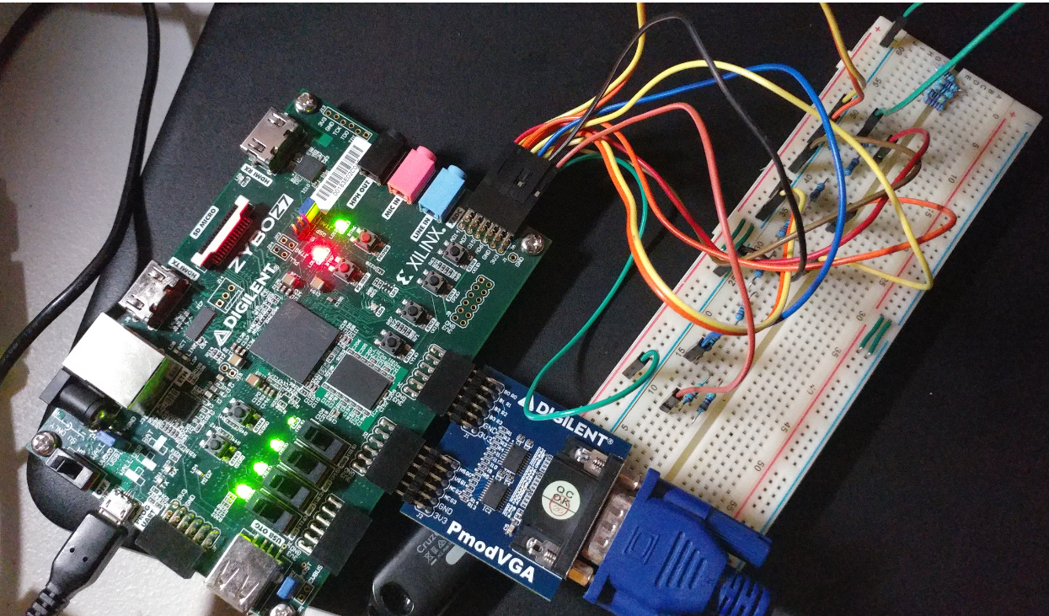 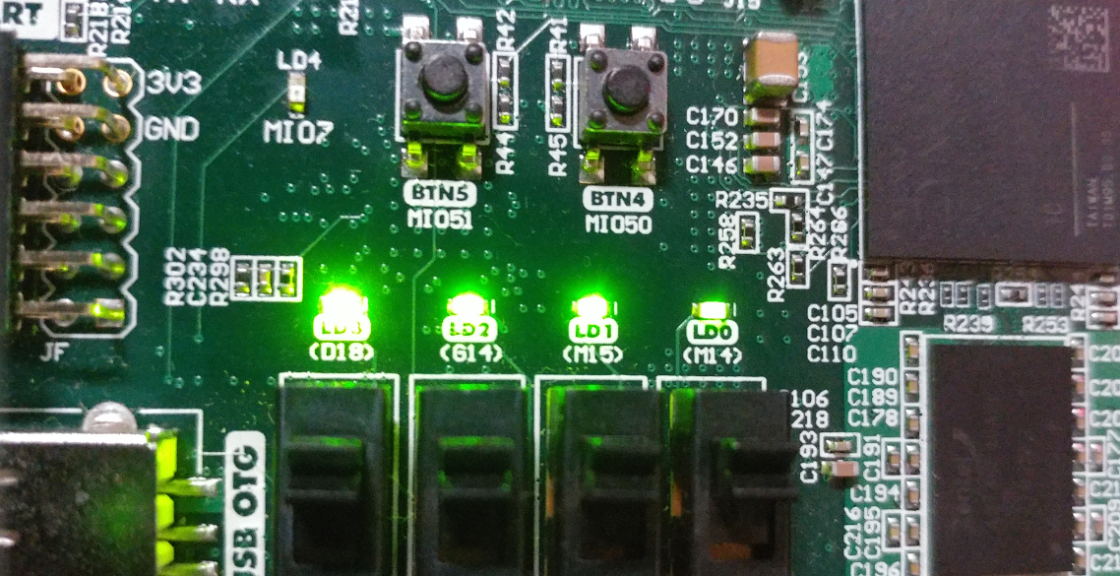

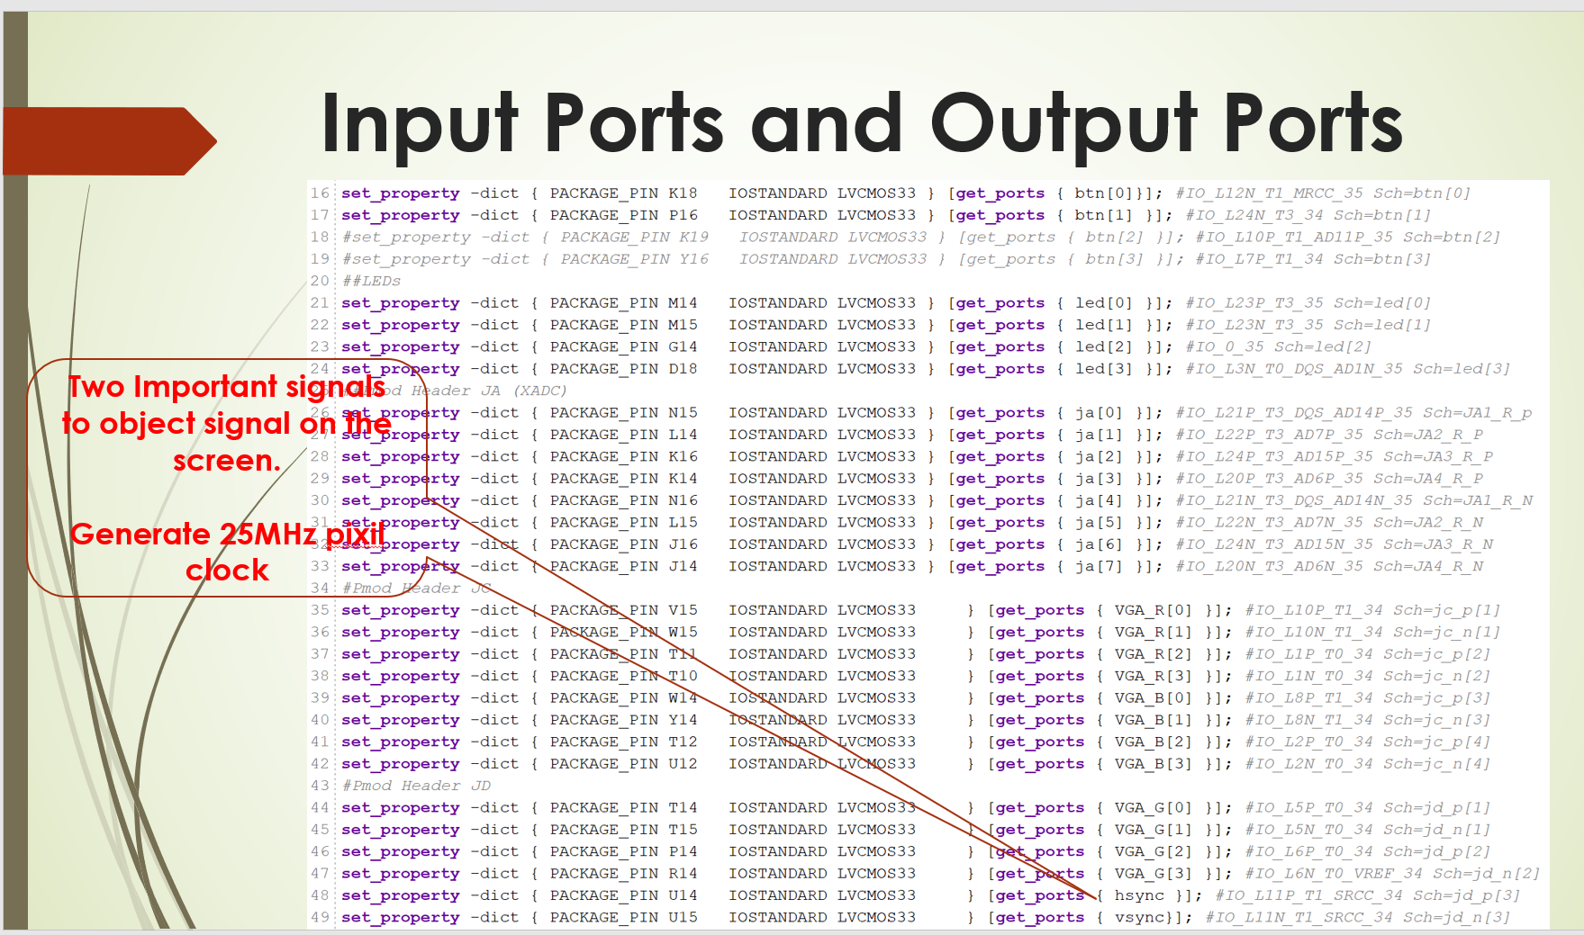

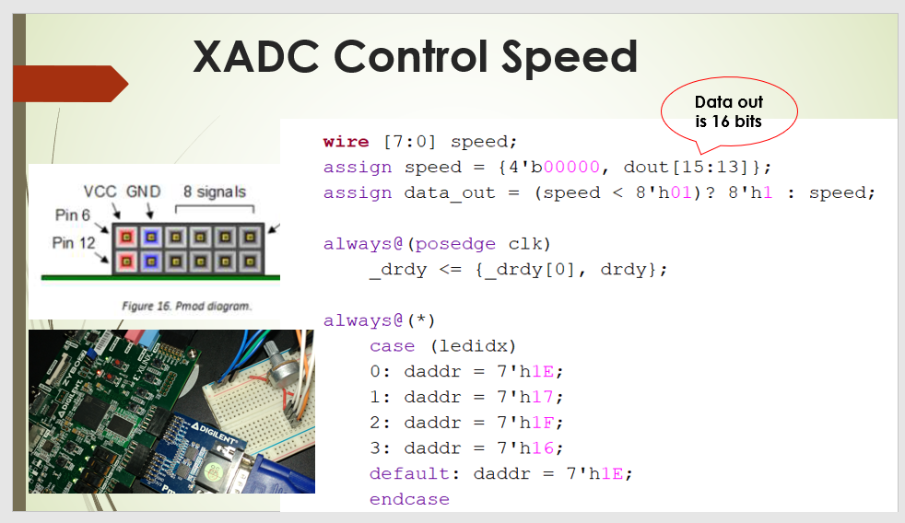

* RISC 32-bit 5 stages Pipelined with Forwarding Unit and Hazard Detector (*Fall 2020 – Adv Computer Architecture I*)

<https://drive.google.com/file/d/1UGjc_aACZLHmnbcP7u7_3vsWSSOOd89l/view?usp=sharing>

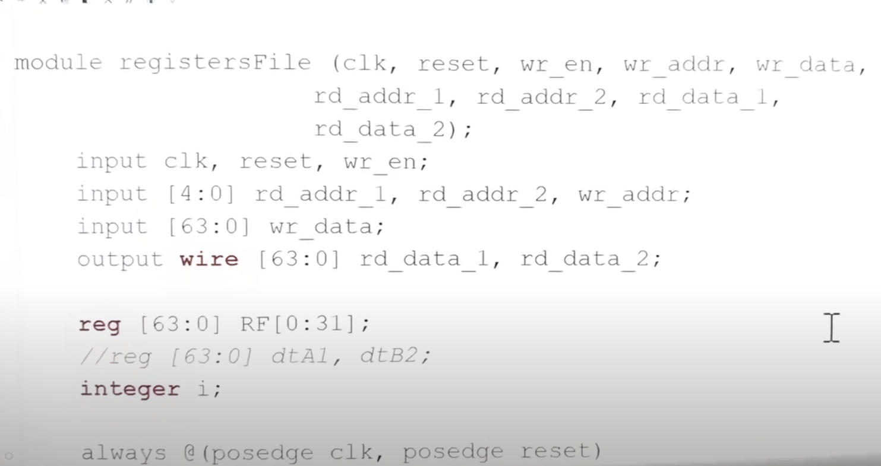 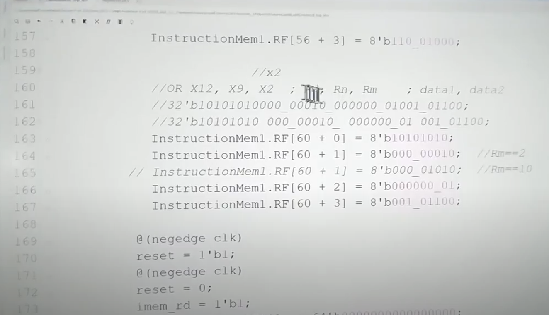

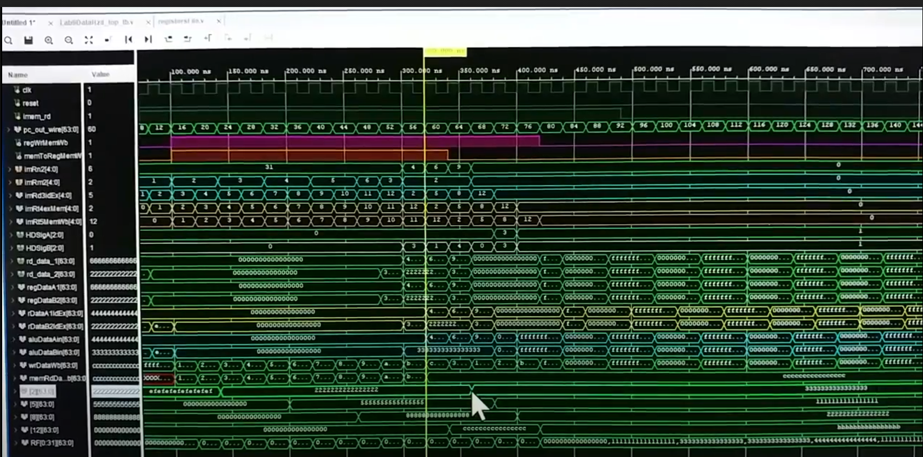

* Real-Time Autonomous Robot (*Fall 2018 - Computer Engr Snr Proj II*)

<https://www.youtube.com/watch?v=9__2CTwlCjk&list=PLWB9IGreRgxzoJ4VC523rkH4-hUHCCX6L&index=1>

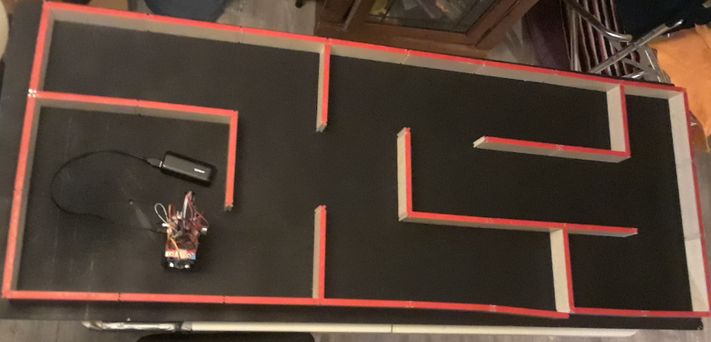 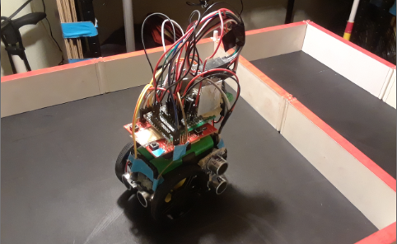

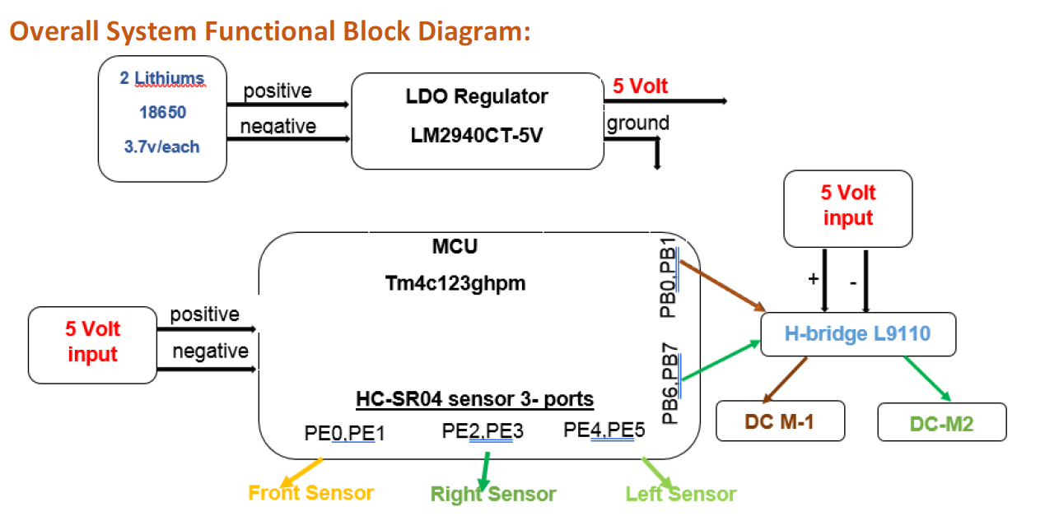

* MIPS Non-Pipelined 32-bit CPU with Barrel Shifter (*Computer Architecture – Fall 2017*)

<https://www.youtube.com/watch?app=desktop&v=e0dxrGOGR4c&t=483s>

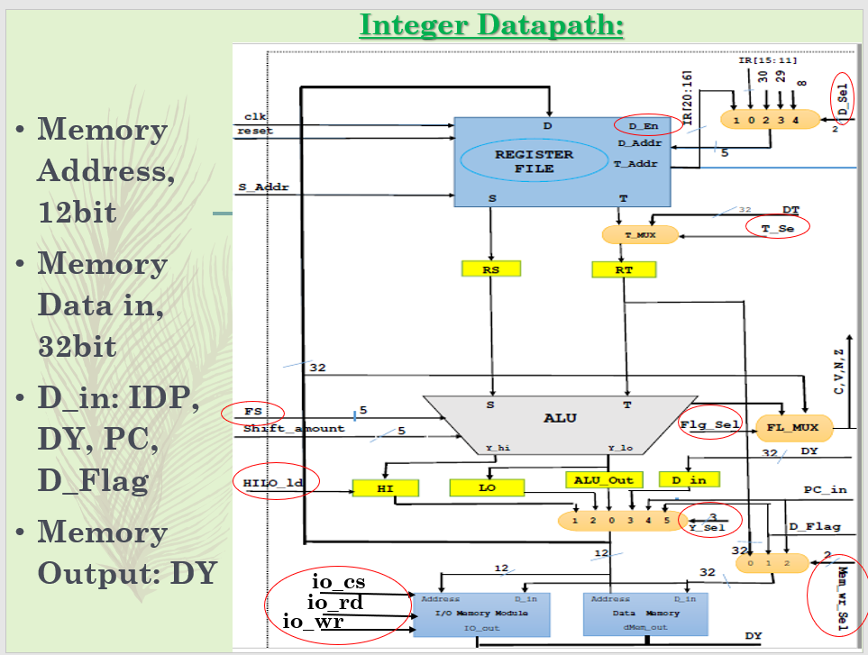

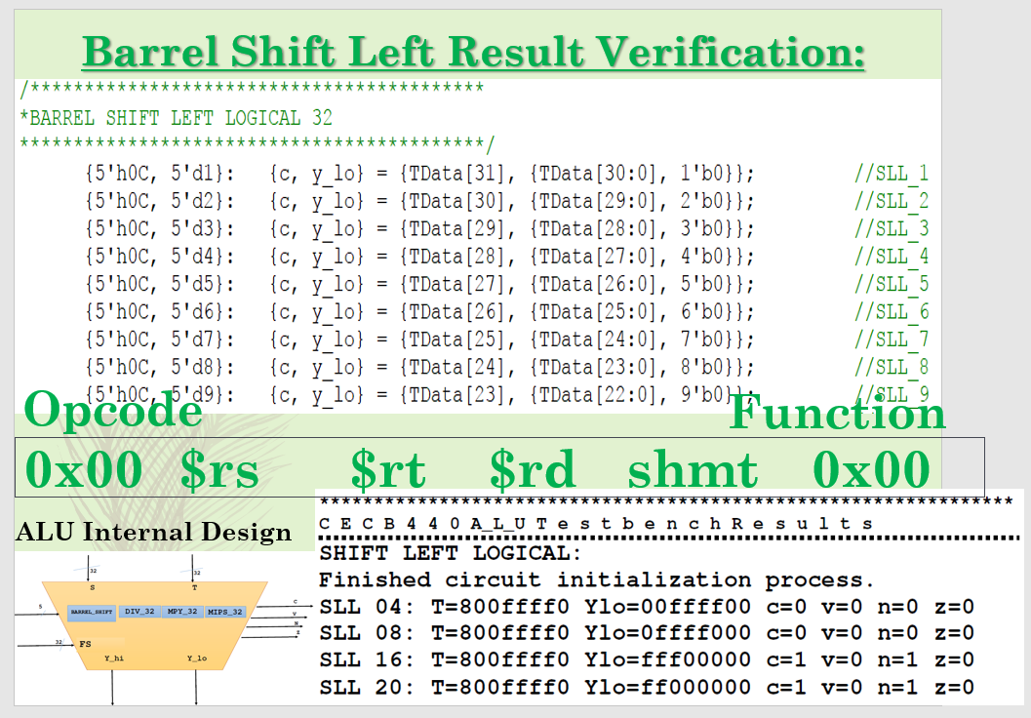

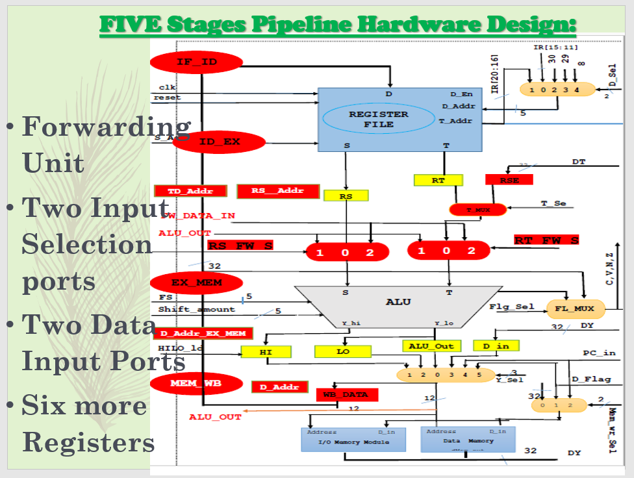

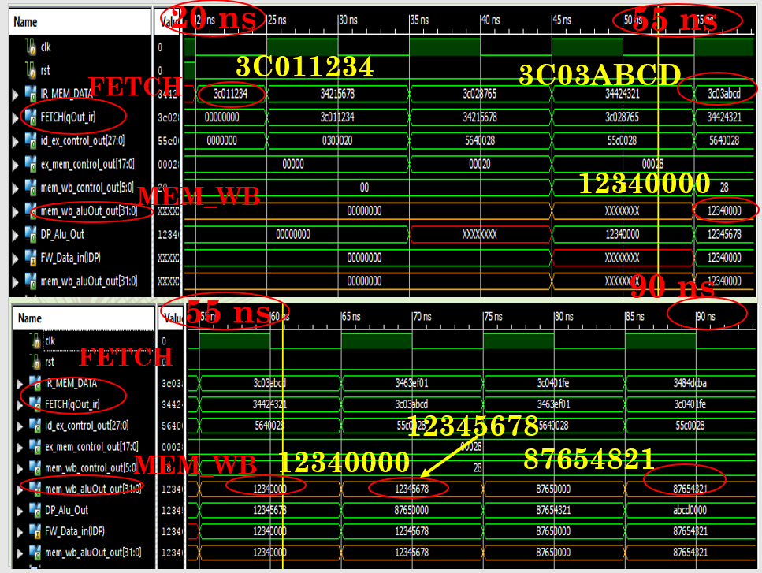

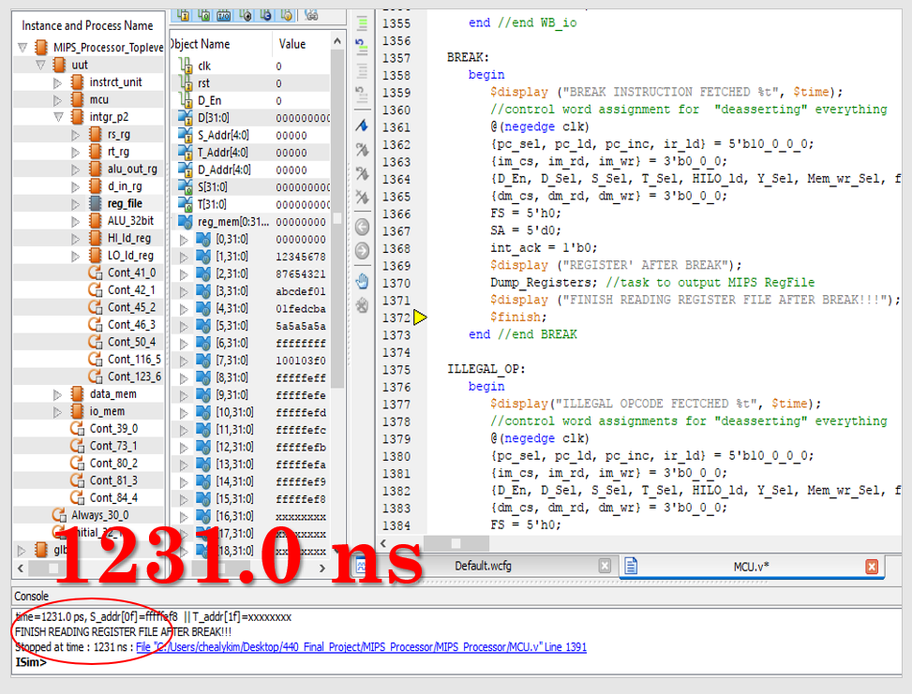

End of Portfolio. Thank you for taking the time to review.

Sincerely,

Julie Kim